# Music Db

You are working on a team that is building a music database. The team is currently building some REST services. You are responsible for building the REST services to manage the Artist, Album and Song entities. The architect has defined the entities as follows:

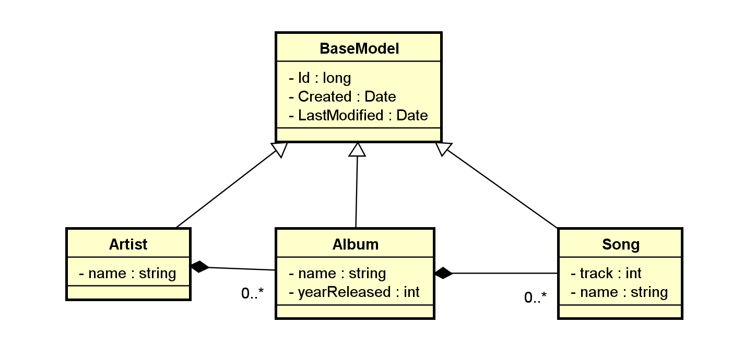

The team has adopted Microsoft WebApi as the framework of choice for all server side development. SQL Server, Entity Framework and code first migrations should be used. Further, the architect has mandated the following technical requirements:

* REST services should support all http verbs required for CRUD operations.
* Entity Framework Database migrations should be used to manage schema and data creation/changes
* The service/repository pattern must be used. Each entity should have its own repository and service.
* All service and repository code should have good unit test coverage. Integration testing is a nice to have but required at this point.
* For this phase the database should be seeded with some test data for validation (see the data.sql file in the Git repository).